Wishlisting Habits, Indecisiveness and Future Planning Among Online Shoppers

Ishita Mazumdar

Article history: |  | Abstract
Submitted: 06 12.2021  Revised: 29.12.2021  Accepted: 20.02.2022 |  | In the world of online shopping, nowadays many people choose to make abundant use of the ‘wishlist’ feature. However, what differs is the timespan of this wishlist. While some people choose to shop only when they need to, add whatever they think they might buy and make a decision by the end of their shopping session, others choose to simply keep browsing. They may spend hours wishlisting products without ever buying anything. The current published researches focus extensively on the personality factors associated with online shoppers and why certain individuals prefer online shopping over conventional offline shopping. The ‘wishlist’ feature of online shopping has not been studied in detail as of yet. This research focuses on wishlisting habits and their correlation with indecisiveness and future planning. Indecisiveness, as measured by the Frost and Shows Indecisiveness Scale (IS), was not found to have any significant correlation with wishlisting. It was found that high wishlisters showed a moderate correlation with non planning, as measured by the Barratt Impulsiveness Scale (BIS 11). This research could have future implications for further advancements in business and consumer psychology. The study could also be furthered to study the browsing habits of people who compulsively search for web shows to watch for hours on end without being able to make a decision on the same.
Keywords:
Online shopping;
Wishlist;
Indecisiveness;
Future planning;
Indecisiveness scale;
Barratt Impulsiveness Scale;
 |  | International journal of Pedagogical Advances in Technology-Mediated Education © 2022
Corresponding author:
Ishita Mazumdar,
MIT WPU.
Email address: ishitamazumdar12@gmail.com

1 Introduction

With the advent of technology, the phenomenon of shopping has undergone a major transformation. From being almost exclusively available as a physical service one had to go to a store to avail, it has now become a technological service through online shopping or e-commerce. The ability of websites to send various data such as text, graphics, images, sounds, animation, or even video make many businesses that utilize commercial website technology to promote their business or called e-commerce.

Despite the explosive growth of e-commerce and the rapidly increasing number of consumers who shop online, very little is known about how consumers make purchase decisions in online environments.

Online shopping apps provide a wishlist option using which consumers can shortlist the products they like and, presumably, intend to buy, for a later date or time. A wishlist allows shoppers to create personalized collections of products they want to buy and save them in their user account for future reference. Wishlists signify a customer’s interest in a product without an immediate intent to purchase.

While it is true that the primary purpose of the wishlist feature in online shopping apps is to keep and save a product for a later date, the timespan of when this ‘later date’ occurs is quite variegated. While some people buy the items on their wishlists in the near future (say, in the next week), others may keep these products in their wishlists for months on end.

In psychology, decision-making (also spelled decision making and decisionmaking) is regarded as the cognitive process resulting in the selection of a belief or a course of action among several possible alternative options.

A major part of decision-making involves the analysis of a finite set of alternatives described in terms of evaluative criteria. When considered in the context of online shopping, the set of alternatives provided to the shopper may not seem infinite. This is known as ‘overchoice’. Alvin Toffler coined the term “overchoice” in his book Future Shock (1970) to describe a world in which there was too much choice to make optimal, satisfying decisions.
Boatwright and Nunes (2001) provide real-world evidence of overchoice at the store level. In their research, they analyzed sales for an online grocer. Consistent with the findings of Dhar (1997) and Iyengar and Lepper (2000), it appears that the larger assortments do more harm than good for shopping.

Corbin suggested that consumers delay purchasing decisions or hesitate in order to get more information about their targeted products. Similarly, consumers feel less uncertain of decisions when they acquire more information. However, if they have too much information about the products they intend to buy, they may experience confusion or difficulty in making choices.

Consumers hesitate to purchase a product because they are not convinced of their real need for a product. Likewise, unless consumers perceive the real need for a product on the Internet, they are likely to hesitate before making an Internet purchase. Therefore, we propose that the lower a consumer’s perceived need for a product or service when shopping on the Internet, the higher their hesitation to purchase the product or service. Thus, it follows that the individuals who engage more in wishlisting activities also engage more in planning, i.e., they anticipate their future needs for certain products and start wishlisting them for when they require the items.

2 Materials and Methods

Data regarding wishlisting habits, indecisiveness and planning was obtained from 138 participants.

Wishlisting habits

Online shopping and wishlisting habits of the participants was studied through a self report form. 8 items, scored on a 5 point likert scale, were used to assess the extent to which the participants use the wishlist option and to discern the extent of the timespan of the wishlist.
Non-mandatory open ended questions were also included in the form to glean further understanding towards participants’ wishlisting habits.

Indecisiveness

The Indecisiveness Scale given by Forst and Shows was used to assess the indecisiveness of the participants. 15 items were scored on a 5 point likert scale to obtain the indecisiveness scores for each participant. The reliability for this scale is 0.83 and has moderate validity.

Planning

The Barratt Impulsiveness Scale (BIS-11) given by Barratt was used to assess the planning of the participants. Only items relating to the self control planning facet were used. 5 items were scored on a 4 point likert scale to obtain planning scores for each participant. Internal consistency was 0.793 and test-retest reliability was 0.80. The scale has moderate validity.

Population characteristics

138 total participants within the age range 18-27 years. 51.5% of all participants were male while 48.5% were females.
The participants were from 22 different major cities of India, spanning 10 states.
35.4% of all participants were in a relationship.
62.5% of all participants were pursuing secondary education while the others were employed.

3 Results and Discussions

Data analysis

Wishlisting and indecisiveness
No significant correlation was found between wishlisting and indecisiveness.

Wishlisting and planning
A weak positive correlation was found between whistling and planning (0.25).
However, when participants were segregated into young adults (18-23 years) and older adults (24-27 years), it was found that a moderate positive correlation existed between wishlisting and planning for the older adults group (0.58).

When a scatterplot is created for 138 participants within the age range 18 to 27 years, only a weak positive correlation is found as can be clearly seen on the adjunct chart contrasting wishlisting and planning scores of the participants.

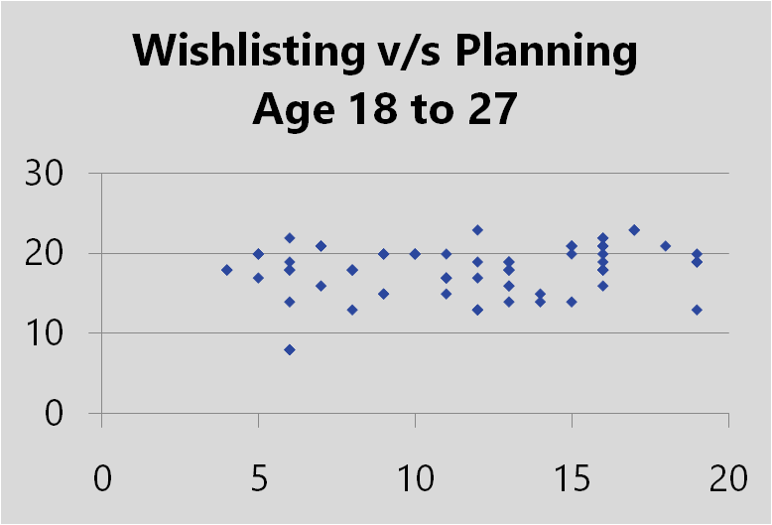

Figure 1: Scatterplot depicting wishlisting versus Planning for all participants

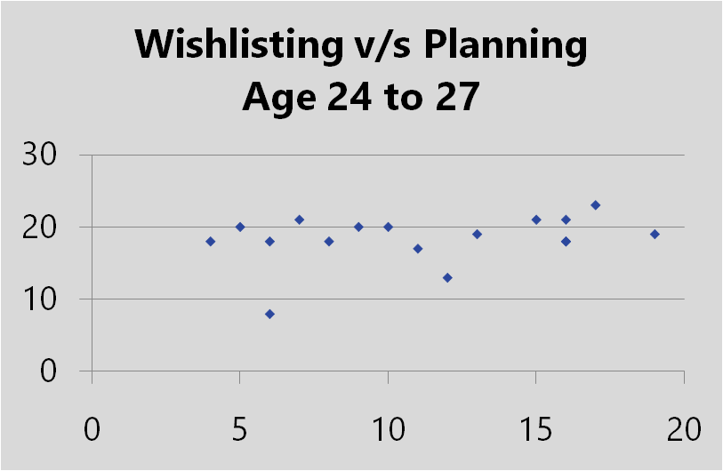

Figure 2: Scatterplot depicting wishlisting versus Planning for a subset of the participants (aged 24 to 24 years)

Age differences

As discussed earlier, it was found that the group of older adults (24-27 years of age) showed a moderate correlation between wishlisting and planning. It is thus worth considering that a stronger correlation may be discerned for an older population. This presents scope for further study. According to some sources, the 25-55 age group engaged the most in online shopping. Thus, a similar research with this population may show promising results.

Gender differences

Contrary to previous researches (Dittmar et al. 2004, Hasan 2010) which stated that men and women hold similar attitudes to online shopping and engage in it to the same level, it was found that of respondents with high wishlisting habits, females were 64.7% while male were only 35.3%

Confusion due to overchoice

The phenomenon of overchoice has briefly been discussed in this study.
Researches (Lee and Lee 2004, Garaus 2018) explore confusion that occurs due to abundance of choice or over-choice which hampers decision making ability of consumers, as confirmed by this research. Confusion due to over-choice and its subsequent hindrance of decision making can also be studied in different contexts, such as browsing habits on online streaming platforms. This presents scope for further study.

4 Conclusion

The hypothesis that wishlisting habits and indecisiveness will show a positive correlation was rejected.
The hypothesis that wishlisting habits and planning will show a positive correlation was accepted.

Conflict of interest statement
The author (Ishita Mazumdar) declares that she has no competing interest.

Statement of authorship
The author (Ishita Mazumdar) has a responsibility for the conception and design of the study. The author has approved the final article.

Acknowledgments

This work was supported by MIT World Peace University. the author would like to thank Prof. Abhijeet Chore (Program Head, Psychology, MIT WPU) and Prof. Madhura Londhe (Professor, Psychology, MIT WPU) for their continuous guidance and support throughout this research endeavor.

References

Alavi, S. A., Rezaei, S., Valaei, N., & Wan Ismail, W. K. (2016). Examining shopping mall consumer decision-making styles, satisfaction and purchase intention. The International Review of Retail, Distribution and Consumer Research, 26(3), 272-303.
Bodendorf, Freimut and Florian Lang. 2009.Automated Services for Market-Based E-Commerce Transactions. Proceedings of the International MultiConference of Engineers and Computer Scientists 2009 Vol I IMECS 2009, March 18 - 20, 2009, Hong Kong
Cho, C. H., Kang, J., & Cheon, H. J. (2006). Online shopping hesitation. CyberPsychology & Behavior, 9(3), 261-274.
Corbin, R.M. (1980). Decisions that might not get made. In: Wallsten, T.S. (eds.), Cognitive Processes in Choice and Decision Behavior. Hillsdale, NJ: Erlbaum, pp. 47–67
Cowart, K. O., & Goldsmith, R. E. (2007). The influence of consumer decision‐making styles on online apparel consumption by college students. International Journal of Consumer Studies, 31(6), 639-647.
Edwards, W. (1954). The theory of decision making. Psychological bulletin, 51(4), 380.
Egeln, L. S., & Joseph, J. A. (2012). Shopping cart abandonment in online shopping. Atlantic Marketing Journal, 1(1), 1.
Hasan, B. (2010). Exploring gender differences in online shopping attitude. Computers in Human Behavior, 26(4), 597-601.
Herbert Alexander Simon (1977). The New Science of Management Decision. Prentice-Hall. ISBN 9780136161448.
https://www.oberlo.in/ecommerce-wiki/wishlists
Gourville, J. T., & Soman, D. (2005). Overchoice and assortment type: When and why variety backfires. Marketing science, 24(3), 382-395.
Factor structure of the Barratt impulsiveness scale, Patton JH, Stanford MS, and Barratt ES (1995), Journal of Clinical Psychology, 51, 768-774.
Fifty years of the Barratt Impulsiveness Scale: An update and review, Stanford MS, Mathias CW, Dougherty DM, Lake SL, Anderson NE, and Patton JH (2009), Personality and Individual Differences, 47, 385-395.
Frost, R. O., & Shows, D. L. (1993). The nature and measurement of compulsive indecisiveness. Behaviour Research and Therapy, 31(7), 683-692
Javadi, M. H. M., Dolatabadi, H. R., Nourbakhsh, M., Poursaeedi, A., & Asadollahi, A. R. (2012). An analysis of factors affecting on online shopping behavior of consumers. International journal of marketing studies, 4(5), 81.
Kukar-Kinney, M., & Close, A. G. (2010). The determinants of consumers’ online shopping cart abandonment. Journal of the Academy of Marketing Science, 38(2), 240-250.
Moore, S., & Mathews, S. (2008). An exploration of online shopping cart abandonment syndrome–a matter of risk and reputation. Journal of Website Promotion, 2(1-2), 71-88.
Orozco-Cabal L, Rodríguez M, Herin DV, Gempeler J, Uribe M. Validity and Reliability of the Abbreviated Barratt Impulsiveness Scale in Spanish (BIS-15S). Rev Colomb Psiquiatr. 2010 Mar 1;39(1):93-109
Park, C. H., & Kim, Y. G. (2003). Identifying key factors affecting consumer purchase behavior in an online shopping context. International journal of retail & distribution management.
Olariu, P. (2021). Shopping Wishlist: Technical Report (Doctoral dissertation, Dublin, National College of Ireland).
Yang, C., & Wu, C. C. (2006). Gender differences in online shoppers' decision-making styles. In e-business and telecommunication networks (pp. 108-115). Springer, Dordrecht.
Zhou, L., Dai, L., & Zhang, D. (2007). Online shopping acceptance model-A critical survey of consumer factors in online shopping. Journal of Electronic commerce research, 8(1), 41.

Biography of Authors

Ishita Mazumdar
A final year psychology honors student at MIT World Peace University, Ishita is an aspirant learner and keen observer who plans to continue her further education in the field of industrial-organizational psychology.
Email: ishitamazumdar12@gmail.com@gmail.com

MIT WPU, Gurgaon, India

